PROJECT BLADE DOCTOR WEBSITE

We are a Pretoria-based company that specialises in sharpening:

Our mission is to provide reliable, fast, precision sharpening with exceptional customer service. By providing you with high-quality sharpening in a fraction of the time, we help to increase the efficiency & success of your business - sharpening your potential.

After extensive research, we have established that the majority of Restaurants etc. are paying exorbitant prices for brand new utensils & instruments. We have as established that the majority of owners have been investing in brand new utensils & instruments as opposed to having the old utensils & instruments just sharpened at less than half the price or more.

* Hunting Safaris’
* Restaurants
* Catering
* Hotels
* Guest Houses
* Garden Services
* Butcheries
* OR Home Use ☺

COLLECTION & DELIVERY AND OR DONE ON PREMISES FOR

YOUR CONVIENCE

*PRETORIA BASED ONLY, RAM courier services to be used outside based Pretoria.

We have been in the Blade-sharpening industry for 11 years & are professionals, as we are utilising **German Machinery**!

FUNCTIONALITY OF THE WEB SITE AND LAYOUT

Example:

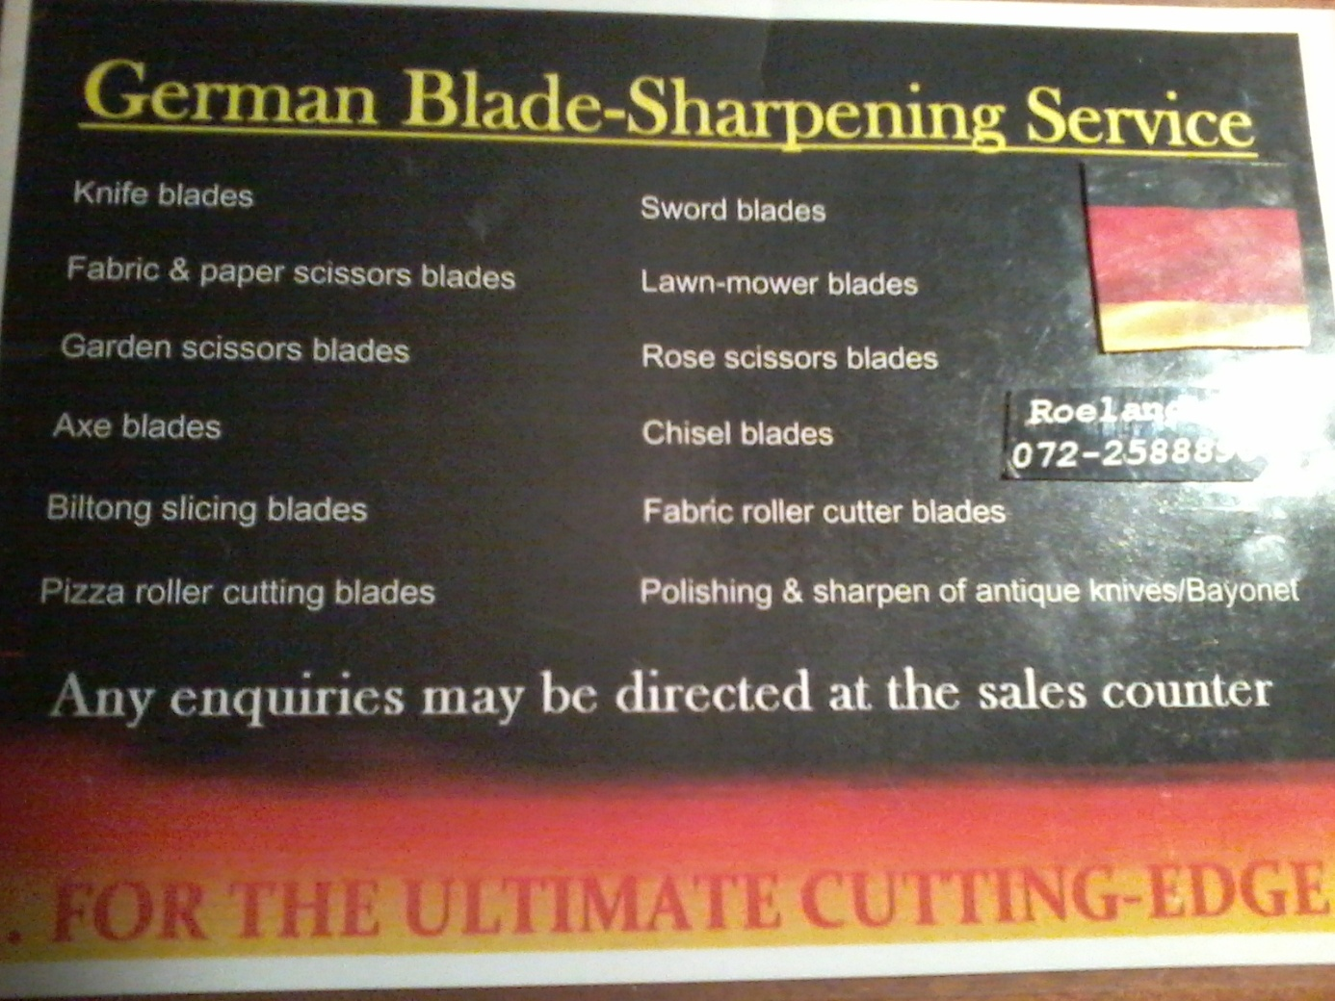

* The web page Background in black
* Heading of web page ( Blade Doctor ) name of company in Red
* Underneath heading ( German Blade-Sharpening Service) in Yellow
* Web page background to have German flag or tint to it to patronize Quality of Nationality.
* The Introduction of the german sharpening services on the opening web page.
* Listing units that can be sharpened and prices to slide down with curser.

***Units and Price List***

* Knife blades R35ea

* Paper scissors blades R30ea

* Hair dressing scissors blades R80ea

* Lawn-mower blades R80ea

* Garden scissors blades R60ea

* Rose scissors blades R40ea

* Axe blades R50ea

* Sword blades R400ea

* Biltong slicing blades R150ea

* Fabric roller cutter blades R30ea

* Pizza roller cutting blades R30ea

* Wood Chisel blades R30ea

* Polishing & sharpen of antique knives/Bayonet.etc. R300ea

* Medical Chisels (e.g. Nose) R500ea

* Other Special Blades can be requested to be serviced and sharpened

***CONTRACTS CAN BE SETUP FOR BUSINESSES FOR FUTURE SERVICES AND DISCOUNTS !***

|  |  |
| --- | --- |
|  |  |

* Before and After pictures to be displayed after scrolling down the page of listing the units that can be sharpened and the price list.

Before and after picture of a knife:

BEFORE: 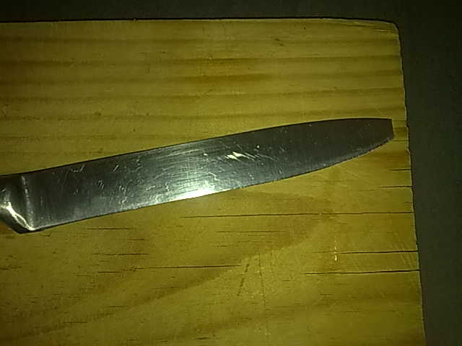 AFTER: 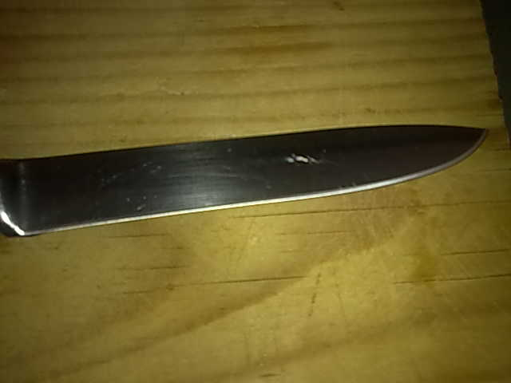

Bayonet:

BEFORE: 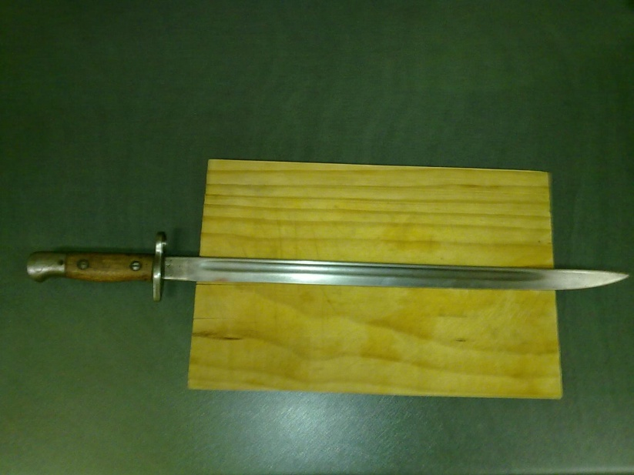

AFTER: 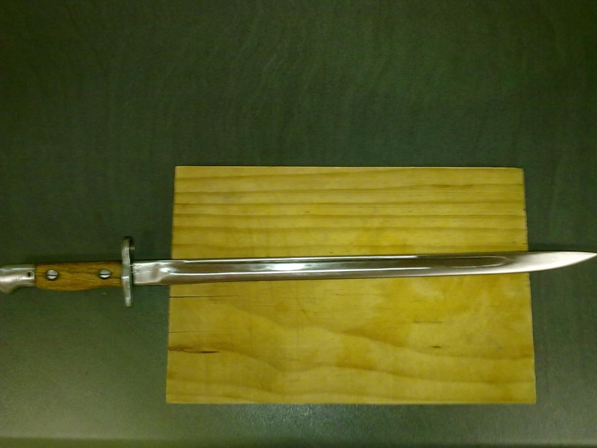

Scrolling down from the page of Before and After a advert to be displayed

Of selling **SHARPENING MACHINERY PRODUCT & TRAINING**

Sharpening Machinery and Training (1 day)

* Product Sale & Training included

FOR

R8500

(Deposit of R1500 REQUIRED)

* Web page have six links on the bottom at the end of the web page namely:

Contact:

* Roeland Hain @ 072 258 8890 call or whatsapp

* Email : [knivedoctor@gmail.com](mailto:knivedoctor@gmail.com)

* Comment Box.

* Number of Views.

* Project Sponsor SirVic ( sponsor Advert popup)

* Interested to sponsor Blade Doctor and become business partners of the company are welcome.

Business proposal are ready to be discussed,

Contact CEO and Founder ( Roeland Hain ) 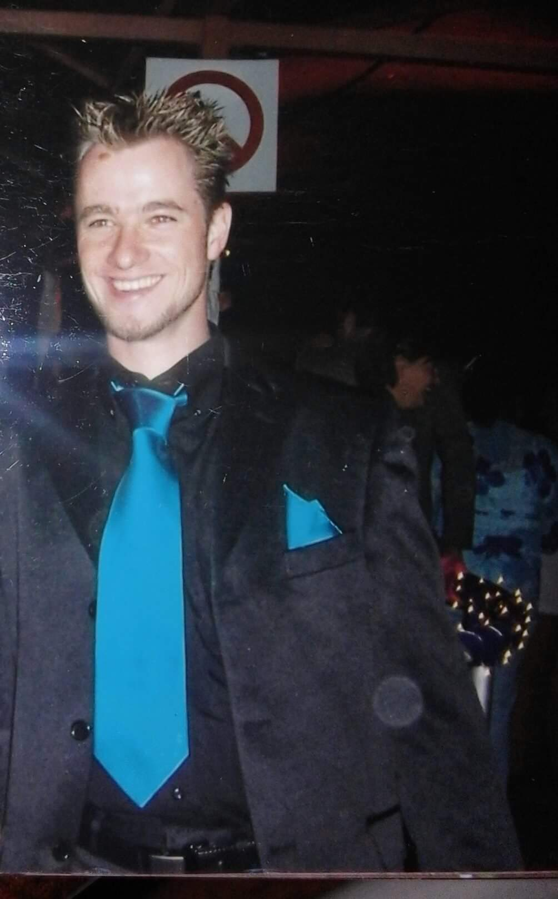



SirVic advert on link.

Displaying : Email: [sirvictradingandprojects@gmail.com](mailto:sirvictradingandprojects@gmail.com)

Office Address: 289 moreleta street, mercury complex, silverton, pretoria